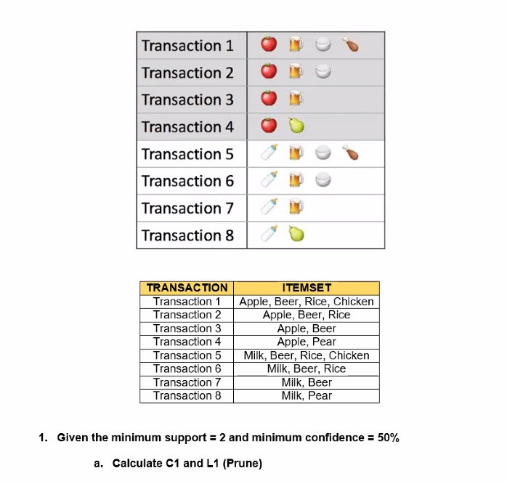

**C1** Table

|  |  |
| --- | --- |
| Itemset | Support Count |
| Beer | 6 |
| Apple | 4 |
| Milk | 4 |
| Rice | 4 |
| Chicken | 2 |
| Pear | 2 |

**L1 Minimum support = 2 transactions**

**L1** Table

|  |  |
| --- | --- |
| Itemset | Support Count |
| Beer | 6 |
| Apple | 4 |
| Milk | 4 |
| Rice | 4 |
| Chicken | 2 |
| Pear | 2 |

**C2**

|  |  |
| --- | --- |
| Itemset | Support_count |
| {Apple, Beer} | 3 |
| {Apple, Rice} | 2 |
| {Apple, Chicken} | 1 |
| {Apple, Pear} | 1 |
| {Apple, Milk} | 1 |
| {Beer, Rice} | 3 |
| {Beer, Chicken} | 2 |
| {Beer, Pear} | 1 |
| {Beer, Milk} | 3 |
| {Rice, Chicken} | 2 |
| {Rice, Pear} | 0 |
| {Rice, Milk} | 2 |
| {Chicken, Pear} | 0 |
| {Chicken, Milk} | 1 |
| {Pear, Milk} | 2 |

**L2 (after pruning itemsets with count < 2):**

|  |  |
| --- | --- |
| Item | Support Count |
| {Apple, Beer } | 3 |
| {Apple, Rice } | 2 |
| {Beer, Rice} | 3 |
| {Beer, Chicken} | 2 |
| {Beer, Milk} | 3 |
| {Rice, Chicken} | 2 |
| {Rice, Milk} | 2 |
| {Pear, Milk} | 2 |

**C3**

|  |  |
| --- | --- |
| Itemset | Support_count |
| {Apple, Beer, Rice} | 2 |
| {Apple, Beer, Chicken} | 1 |
| {Apple, Beer, Milk} | 1 |
| {Beer, Rice, Chicken} | 2 |
| {Beer, Rice, Milk} | 2 |
| {Beer, Chicken, Milk} | 1 |
| {Rice, Chicken, Milk} | 1 |
| {Rice, Pear, Milk} | 0 |

**L3** table (after pruning itemsets with count < 2)

|  |  |
| --- | --- |
| Itemset | Support_count |
| {Apple, Beer, Rice} | 2 |
| {Beer, Rice, Chicken} | 2 |
| {Beer, Rice, Milk} | 2 |

**Computing the confidence**

|  |  |  |
| --- | --- | --- |
| **Rules** | **Support** | **Confidence** |
| **Apple ^ Beer -> Rice** | **2** |  |
|  |  |  |